**Architectural Project Planning**

**Shopping Mall Design**

**Skill Teach International Karachi**

**Teacher: Sir Ayaz**

**Proposal By: Mohammad Zeeshan & Muhammad Waleed Raza**

**Software :Autocad 2007 + 2015**

**Batch 2 Section A Roll# 58**

**We plan all projects in 3 stages. Which stage are you in? Stage A gains vital council permissions. Stage B is the technical and pricing phase. Stage C is the building and moving in phase.**

**Stage A – Design & Planning . Start, Plan, Valid, Council**

**Stage B– Contract & Construction Agreement, Map Passing**

**Stage C– Quantity & Cost, Costs, Floor, Shops, Elevators, Stairs  
  
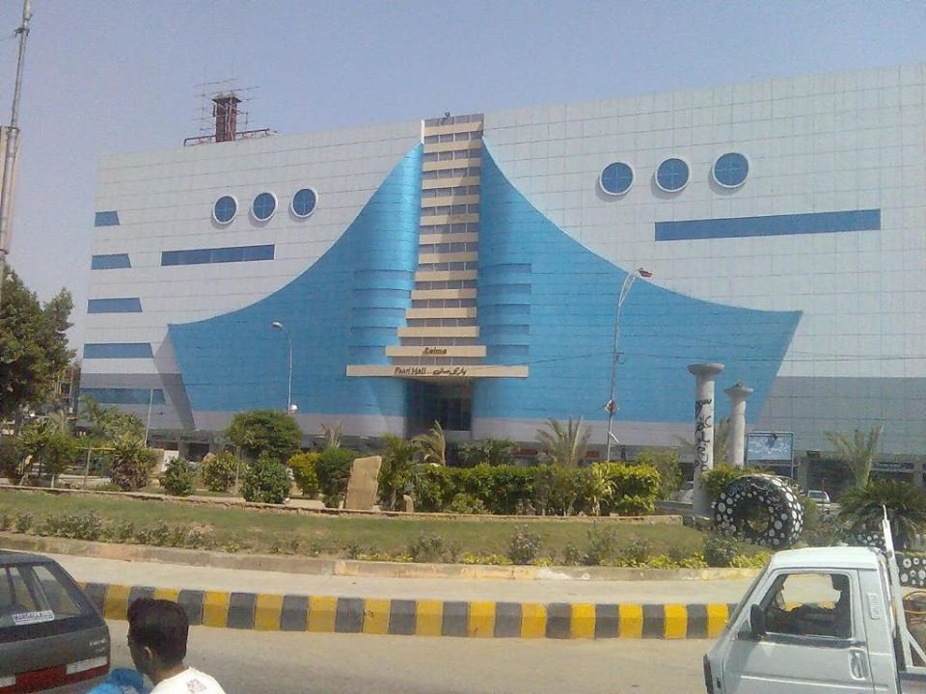**

**Proposal: We are creating a architectural design of shopping mall this shopping mall look like a Saima Pari Shopping Mall. Our team will visit saima pari mall. after we have visited its area approx. 2000ghzs. Its have 4 floor with ground floor and its have at least 150 shops .The Project consists as approved Basement (Air Raid Shelter) + Ground Floor (Shops) Ist to 3rd (Car Parking) + 4th Floor . This is total area 7339 sq.ft and its length 110 sq.ft and width 66 sq.ft**

|  |  |  |
| --- | --- | --- |
| **SHOWROOMS / SHOPS** | **Ground** | **7339.75 (Sq.ft)** |